Ionic Formula Worksheet

part a: Writing Ionic Formula
Write the ionic formula for Zinc chloride
Step 1. Write the symbols for each element
Zinc – Zn Chloride – Cl
Step 2. Write down the charge for the cation (positive ion) and anion (negative ion)
Zn²⁺ Cl⁻
Step 3: Combine cation with anion and swap charges
Zn⁻Cl²⁺
Step 4: Remove charges and move numbers to the bottom
ZnCl² ZnCl₂
Try to work out the formula of the following ionic compounds
Sodium chloride Magnesium oxide
Step 1: Step 1:
Step 2: Step 2:
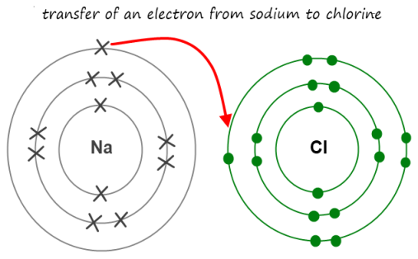
Step 3: Step 3:
Step 4: Step 4:

Potassium Iodide Calcium oxide
Step 1: Step 1:
Step 2: Step 2:
Step 3: Step 3:
Step 4: Step 4:

Write chemical formulas for the compounds in each box. Example: The first box is the intersection between the “zinc” cation and the “chloride” anion, so you should write “ZnCl₂”, as shown.
 | zinc | iron (II) | iron (III) | nickel | silver | lead
chloride | ZnCl₂
iodide
bromide
oxide
sulphide
flouride

part b: Naming Ionic compounds
When naming ionic compounds you must use the following naming rules
1. Always name the metal ion (cation) first
2. The anion is named second and is not capatilised
Nacl – Sodium chloride
Write the names of the following Ionic compounds
A little bit more!!!
Work out the names of the following Ionic compounds in your workbook.
CaO AgBr
BaO CdF₂
PtO CaF₂
Al₂O₃ AuF₂
Fe₂S₃ ZnCl₂
LiCl LiS
- CrO
Cation –
Anion –
Name -

- HgS
Cation –
Anion –
Name -

- AlF₃
Cation –
Anion –
Name -

